DEPARTMENT OF ELECTRICAL ENGINEERING & ELECTRONICS

Project Plan for Over the board Chess AI opponent
Author: Edward Collins (201743271)
Project Supervisor: Dr Lee Devlin
Project Assessor: …name of assessor…

Declaration of academic integrity

By submitting this work, I confirm that I have read and understood the University’s Academic Integrity Policy.
By submitting this work, I confirm that I have acted honestly, ethically and professionally in conduct leading to assessment for the programme of study.
By submitting this work, I confirm that the work I am submitting is my own. I have not commissioned production of the work from a third party or used artificial intelligence software in an unacceptable manner to generate the work*. I have not copied material from another person or source, nor committed plagiarism, nor fabricated, falsified or embellished data when completing the attached piece of work. I have not colluded with any other student in the preparation and/ or production of this work.
*Software applications include but are not limited to, ChatGPT, Bing Chat, DALL.E, Bard

- with.
- To Test and Validate the system by testing the integrated system's performance, measuring its speed, accuracy, and reliability across a series of test games and board positions.

To produce a comprehensive final project report detailing the project's design, implementation, testing methodology, results, and conclusions. Tables of contents, figures, etc.

Section Title | Page
Declaration of Academic Integrity | 1
Project Scope | 2
Project Objectives | 2
Project Requirements | 3
Work Packages | 4
Skills and Resource Audit | 10
Appendix 1: Gantt Chart | 11
Appendix 2: Risk Assessment Form | 12
Appendix 3: FYP Ethics Self-Assessment | 17

Project scope
This project aims to build an over the board chess AI opponent. This will be able to determine the position of the chess pieces on the board in real time using a camera mounted above the chessboard. The system will process the visual information to understand the current game state, identify the human player's move, and then use the Stockfish chess engine to suggest a move to reply with. The final output will be the AI's chosen move, displayed to the user with either standard algebraic notation, or a chessboard with the newly moved piece being highlighted.
The project scope is to focus on the software implementation of the vision and logic systems. The physical output is limited to a text-based or simple graphical user interface display of the AI's move.

Project Objectives
- To assemble a stable physical rig with a camera mounted above a standard chess board.
- To develop and code a computer vision system that can reliably take a raw image of the board and output the game state in with at least 99% accuracy for piece location.
- To create a software interface that allows the computer vision module to communicate with the Stockfish chess engine, sending the human's move and receiving the AI's calculated response.
- To allow the AI to play with both the white and black pieces (not at the same time).
- To Create a User Interface to allow the project to be played

Project Requirements

Category Functional requirements
Identifier | Description
F1 | The system shall successfully detect the boundaries of the chessboard from a top-down camera image.
F2 | The system shall segment the detected board into 64 individual square images.
F3 | The system shall be able to determine if a square is occupied by a white piece, a black piece, or is empty.
F4 | The system shall detect a change in board state between two consecutive images to determine the human player's move.
F5 | The system shall use stockfish to suggest moves to reply with and will display them either in algebraic notation or with an image of the chessboard showing the piece moved

Category Non-functional requirements
Identifier | Description
NF1 | The processing time from the human moving a piece to displaying the AI's move shall be less than 10 seconds.
NF2 | The square occupancy detection (empty vs. white vs black) shall have an accuracy of over 99%.
NF3 | The piece detection shall have an accuracy of over 95%.
NF4 | The system should be able to cope with variations in ambient lighting. (shall be tested in different environments)

Category Hardware requirements
Identifier | Description
H1 | A standard chess set is required.
H2 | A camera and a mounting rig to hold the camera in a fixed, top-down position.
H3 | A computer capable of running Python, Stockfish, and OpenCV

Category Software requirements
Identifier | Description
S1 | The programming language used will be python
S2 | The OpenCV library will be used for the computer vision tasks.
S3 | The Stockfish chess engine will be used to produce the AI response

Work packages

WORK PACKAGE DESCRIPTION
WP Title: | Project initialisation | WP number | 1
Start Event: | Start of semester 1
Duration: | 3 weeks
Objectives:
- Submit completed project plan.
- Become more familiar with required python libraries.

Task Description:
- Create project plan with objectives and requirements.
- Research existing projects on chess recognition.
- Produce a Gantt chart.
- Submit risk assessment.
- Learn and practise using OpenCV, TensorFlow, and Stockfish.

Inputs:
- Initial specification.
- Project plan template.

Interfaces/links with other tasks or WPs:
- This is required before any other work packages can begin.
Deliverables:
- Risk assessment will be completed and approved.
- Project plan will be completed.
- Sufficient knowledge of python libraries will be attained.

WORK PACKAGE DESCRIPTION
WP Title: | Select, order and assemble physical components | WP number | 2
Start Event: | WP1 is completed
Duration: | 2-3 weeks (depending on delivery times)
Objectives:
- To assemble the camera and the camera stand.
Task Description:
- Choose a chess set, camera stand, and camera.
- Complete and submit component order form.
- Assemble Camera and Camera stand and ensure that it is stable and safe.

Inputs:
- Physical components are required.
Interfaces/links with other tasks or WPs:
- Risk assessment must be approved first (WP1).
- Required for software from WP3 to be tested.

Deliverables:
- All physical components will be obtained and assembled.

WORK PACKAGE DESCRIPTION
WP Title: | Computer vision software | WP number | 3
Start Event: | WP 1 is completed
Duration: | 4 weeks
Objectives:
- To develop the software code that processes an image of the chessboard.
Task Description:
- Ensure that the python code is able to access the image from the camera.
- To create software that will detect the edges of the board and warp the board image so that an image of the board as a square is formed.
- If detecting edges of the board is unreliable due to chessboards often having a boarder, then the above will be done using the squares on the board.
- To split the resulting image into 64 small images of each square of the board for WP4.

Inputs:
- Image output from camera
Interfaces/links with other tasks or WPs:
- Required for WP4
- Can be started in parallel with WP2, however cannot be tested and therefore completed until WP2 is completed.
Deliverables:
- Software created to detect the edges of the chessboard.
- To output 64 small images of the board

WORK PACKAGE DESCRIPTION
WP Title: | AI software | WP number | 4
Start Event: | WP 3 is completed
Duration: | 5 weeks
Objectives:
- To develop the software to recognise a piece from an image.
Task Description:
- To gather a large set of training data using the code in WP3 for taking pictures of the pieces.
- Labelling the above pictures (either manually or automatically).
- Creating an AI model which will use the training data.
- To incorporate a prediction function which returns which piece it believes is most likely to be shown in a given input picture.
- To test the accuracy of this to ensure that it meets the requirements set out above.

Inputs:
- Images from WP3
Interfaces/links with other tasks or WPs:
- WP3 must be completed first to provide training data.
Deliverables:
- To develop the software to recognise a piece from an image with 95% accuracy and to have a 99% accuracy at detecting whether a square is vacant or not.

WORK PACKAGE DESCRIPTION
WP Title: | Chess engine software | WP number | 5
Start Event: | WP1 is completed
Duration: | 1 week
Objectives:
- To set up the Stockfish engine.
- Ensure it can communicate with Python.
Task Description:
- Install the Stockfish chess engine.
- Use the python-chess library to create a communication interface.
- Write a script that can push a human move to the engine and request a move from the engine.
- Ensure that the Elo rating of the machine can be set.

Inputs:
- None
Interfaces/links with other tasks or WPs:
- Required for WP6.
- Can be done in parallel with WP2, 3, or 4.
Deliverables:
- A standalone script that can play a game of chess against Stockfish (via text command inputs).

WORK PACKAGE DESCRIPTION
WP Title: | Final software completion | WP number | 6
Start Event: | WP 3, 4, & 5 are all completed
Duration: | 2 weeks
Objectives:
- To have a fully functional Over the board Chess AI opponent.
Task Description:
- Combine the software produced by WP 3, 4, & 5.
- Test to ensure that all parts of the software work together.
- Ensure that the AI can also play with white (since human-moved black pieces may be harder to see).

Inputs:
- WP 3, 4, & 5
Interfaces/links with other tasks or WPs:
- Integrates with WP 3, 4, & 5 to form the complete system.
Deliverables:
- Complete all software relating to the project.
- To have a fully functional Over the board Chess AI opponent which meets the requirements set out above.

WORK PACKAGE DESCRIPTION
WP Title: | project completion | WP number | 7
Start Event: | Project is fully functional
Duration: | 3 weeks
Objectives:
- Project abstract will be written.
- Bench inspection will be completed.
- Project report will be written

Task Description:
- Write project abstract.
- Write project report.
- Ensure that the machine works well in the location and with similar lighting as where the bench inspection will take place.

Inputs:
- Rest of the project.
Interfaces/links with other tasks or WPs:
- Mostly requires WP6, though report and abstract may be started earlier.
Deliverables:
- All documentation completed.

Skills and Resource Audit

Skills Audit:
Skill | Level | Training needs
Python programming | intermediate | Learning using w3schools
OpenCV Library | intermediate | Learning using online OpenCV documentation
Chess | basic | Completed
Stockfish | basic | Learning using online Stockfish documentation
Tensorflow library | intermediate | Learning using w3schools

Resource Audit:

Resource | Availability | Alternatives
Camera | Available to buy online | Use my own
Camera stand | Available to buy online | Make a camera stand
Chess set | Available to buy online | Use my own

Appendix 1. A Gantt chart (1 Page)

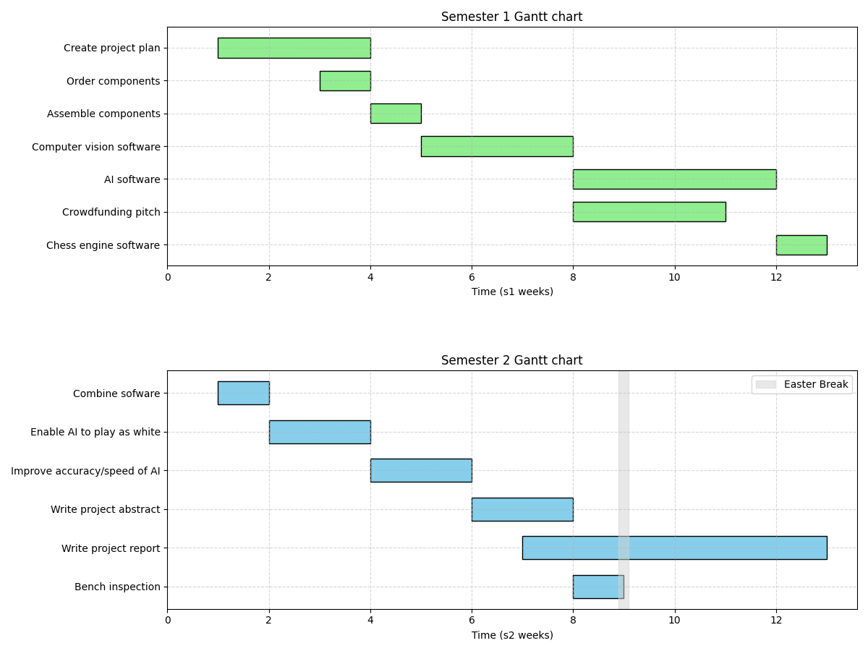

Appendix 2. The risk assessment form.


Risk Assessment Report

Risk Assessment ID: sgecoll4_2025-09-29-11-25-07
Expiry Date: 29/09/2026 (unless environment has changed)

Risk Assessor Details:
MWS Username: sgecoll4
Name: Edward Collins
Email: sgecoll4@liverpool.ac.uk

Location Details:
School: School of Electrical Engineering, Electronics and Computer Science
Department: Electrical Engineering and Electronics
Building: Electrical Engineering-Block A
Space Ref: 4th floor lab space
Location Notes:

Task/Activity Details:
Task/Activity: A camera will be mounted on a stand which could potentially fall over and cause minor injury, this risk will be minimised by ensuring the stand has a sturdy base to ensure it does not fall over.

The camera may fall off the stand and have similar consequences, the camera will be securely attached to the stand to minimise this risk.
Person(s) Affected: people close to the project.

Supervisor Details:
Research Group: other
Supervisor Name: Dr. Lee Devlin (ljdevlin) Supervisor Email: ljdevlin@liverpool.ac.uk Additional Notes:

Colour Key:

Likelihood | 5 | 5 | 10 | 15 | 20 | 25
 | 4 | 4 | 8 | 12 | 16 | 20
 | 3 | 3 | 6 | 9 | 12 | 15
 | 2 | 2 | 4 | 6 | 8 | 10
 | 1 | 1 | 2 | 3 | 4 | 5
 |  | 1 | 2 | 3 | 4 | 5
 |  | Consequence

Likelihood/Consequence:

Likelihood |  | Consequence
Very unlikely | 1 | Insignificant – no injury
Unlikely | 2 | Minor – minor injuries needing first aid
Fairly likely | 3 | Moderate – up to seven days absence
Likely | 4 | Major – more than seven days absence; major injury
Very likely | 5 | Catastrophic – death; multiple serious injury
Likelihood(L) x Consequence(C) = Result(R)

Result/Action:

Result | Action to be taken
1-4 Acceptable | No further action but ensure controls are maintained
5-9 Adequate | Look to improve at next review.
10-16 Tolerable | Stop activity and review current controls
17-25 Unacceptable | Stop activity with immediate effect, and rethink the entire experiment

Likelihood(L) x Consequence(C) = Result(R) Additional Controls Required(Y/N)

Identified Hazard | Control Measures | L | C | R | Y/N
stand falling over | A large/heavy stand will be used to make the camera stand more steady | 3 | 1 | 3 | N
camera falling off stand | The camera will be securely attached to the stand | 2 | 1 | 2 | N

No Additional Controls required at this time.

No attached files for this Risk Assessment.
Local Area Rules:

Fire Evacuation Location:
In front of Harold Cohen Library

Emergency Arrangements:

No Emergency Arrangements identified at this time.

Risk Assessor Notes:
Apologies if I've made any mistakes

Supervisor Notes:
No issues, this is a very low risk project.
Risk Assessment Status:
Approved by Supervisor.

Appendix 3. FYP ethics self-assessment.

